Tortoise/Turtle Value Chain GIS Project Report
Author: Lawrence Kofi Amoako Date: January 2026 Data Sources: Primary survey data (51 respondents from Half Assin, Nkawkaw, Tamale), HDX (roads and admin boundaries), ICPAC Geoportal (agro-ecological zones). Tools Used: QGIS for mapping and analysis, SankeyMATIC for diagram.

1. Introduction
This GIS project analyzes the value chain of tortoise and turtle products in Ghana, focusing on origin-destination flows, exploitation pressure, habitat differences, and intervention leverage points. Based on the field work, the study surveyed 51 respondents across three locations: Half Assin (high rainforest), Nkawkaw (semi-deciduous forest), and Tamale (savannah). The goal is to visualize how products move from sourcing in rural habitats to local communities, middlemen, roadside/highway markets, and urban markets, highlighting conservation opportunities in an unregulated trade.
The project integrates multiple analyses into a composite thematic map and a Sankey diagram, providing a comprehensive view of the chain. Total annual volumes from survey data are 522.5 in Half Assin, 71.5 in Nkawkaw, and 2687 in Tamale, with savannah showing the highest commercial activity.

2. Methodology

Data Collection and Processing
- Survey Data: Excel CSV with 51 points (latitude, longitude, Location, Volume_Midpoint, Role). Processed in QGIS: Aggregated to 3 origin points (mean coordinates, sum volume) using "Mean coordinate(s)" and "Statistics by categories".
- Base Layers: Ghana admin boundaries (gha_admin2), roads (hotosm_gha_roads_lines_shp), agro-ecological zones (ghanaAEZ).
- Flows: Used Geometry Generator in origins layer to create all-to-all lines to destinations (local, roadside, urban markets like Kejetia, Makola, Danso Roadside).
- Styling: Graduated origins by total volume (reds), categorized habitats (dark green high rainforest, light green semi-deciduous, yellow guinea savannah, orange sudan savannah, light brown coastal savannah, sky blue Volta Lake).
- Labels: Cartographic placement with manual move tool for non-overlapping positions.
- Sankey Diagram: Flows proportional to survey totals, created in SankeyMATIC.
All layers in EPSG:4326. GeoJSON exports for standalone use.

3. Results
The results are presented in a composite thematic map (Figure 1) and Sankey diagram (Figure 2), featuring all analyses as one cohesive view. The map shows spatial flows, pressure, and habitats, while the Sankey quantifies proportions.

Figure 1: Composite Thematic Map
This map integrates origin-destination flows, exploitation pressure, and habitat zones into one visual. Origins (Half Assin, Nkawkaw, Tamale) are sized and colored by total annual volume (larger/redder = higher pressure, from 71.5 in Nkawkaw to 2687 in Tamale). Red flow lines with arrows show product movement from habitats to destinations (local communities, Danso Roadside Market, Kejetia Market, Makola Market). Habitats are categorized: dark green high rainforest (southwest, direct hunting), light green semi-deciduous (central), yellow guinea savannah (north-central), orange sudan savannah (north), light brown coastal savannah (southeast), sky blue Volta Lake. Labels are placed cartographically for clarity.
The map highlights differences: short, direct flows in rainforest (decentralized, local-focused), longer commercial flows from savannah to urban markets. Pressure heatmap idea is embedded via point sizes, showing highest exploitation in Tamale savannah. Leverage points are visible as line convergence at roadside/urban markets.

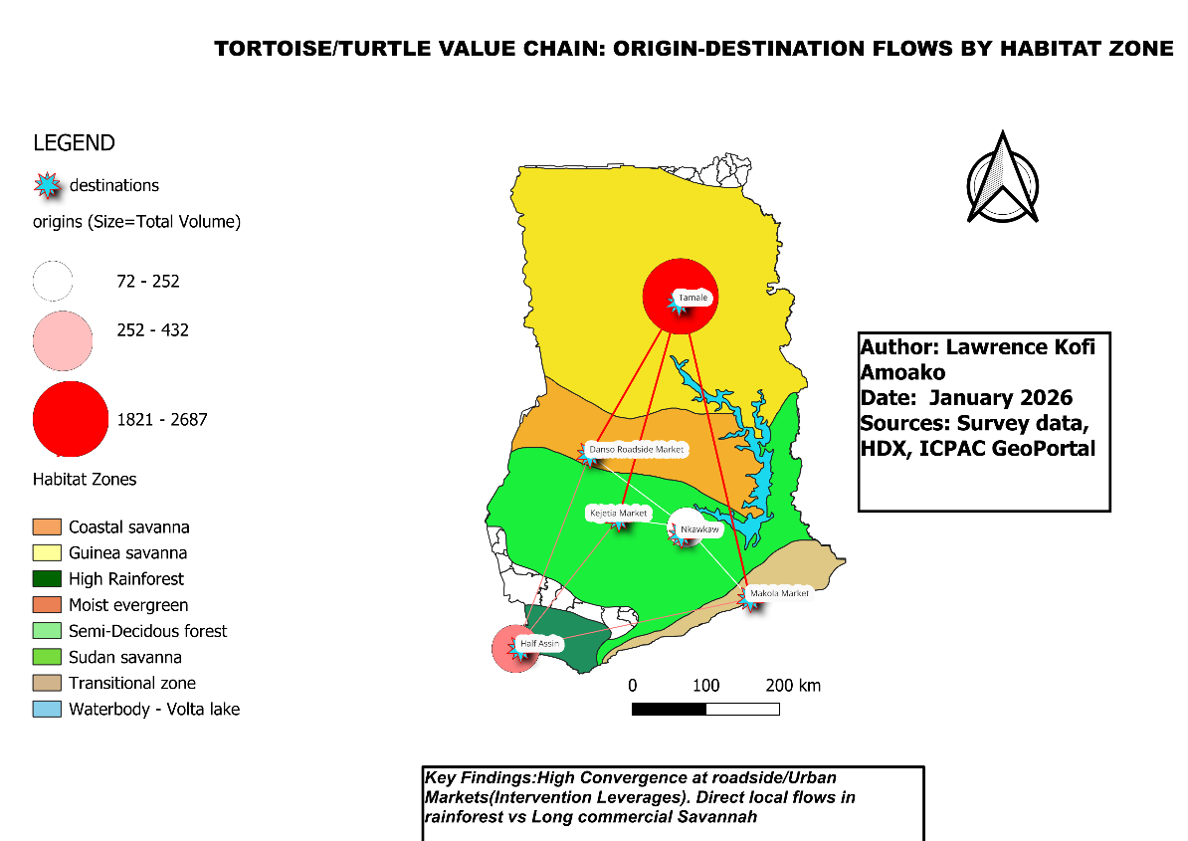

Figure 2: Sankey Diagram
With the same idea as the map, this Sankey diagram quantifies flows by habitat, using exact survey totals. It shows proportional movement: High Rainforest (522.5) mostly to local community (60%) with less to markets (40%); Semi-Deciduous (71.5) similar local dominance; Savannah (2687) heavily commercial through middlemen/vendors (100% vendors in data) to roadside/urban (56%). Flows are thicker from savannah, emphasizing commercial chains.
The diagram reinforces the map's spatial story in a quantitative way: convergence at roadside/urban markets (high total inflow) indicates leverage for interventions, with savannah showing the highest volumes and rainforest more decentralized.

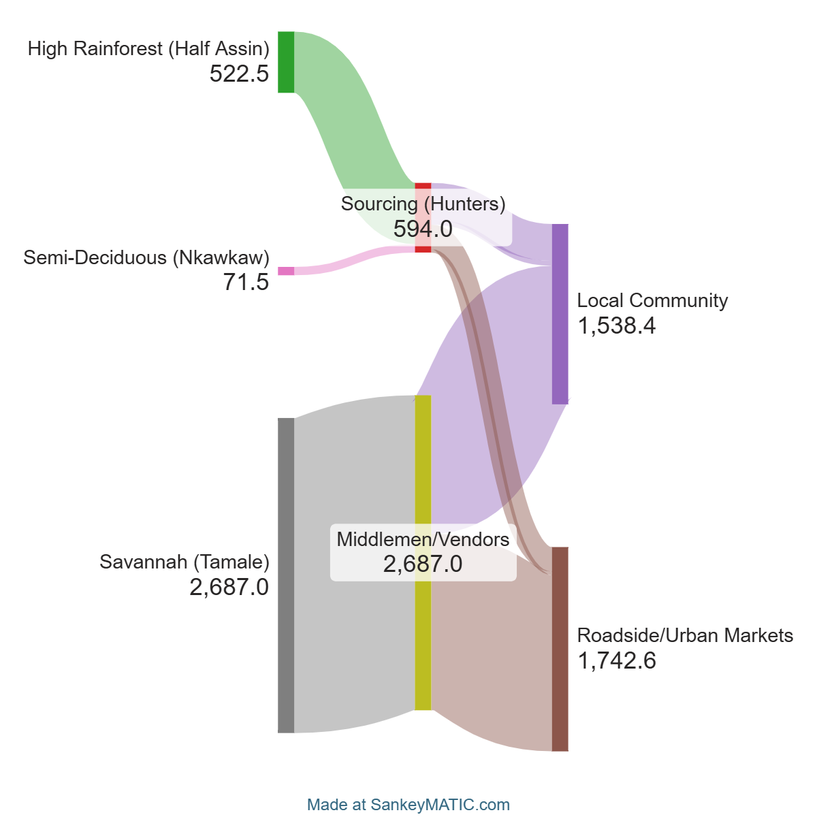

4. Discussion
The composite map and Sankey reveal key patterns: savannah (Tamale) has the highest pressure (2687 annual volume) and commercial flows, with middlemen/roadside as bottlenecks for enforcement. Rainforest (Half Assin) shows moderate pressure (522.5) and direct local chains, suggesting community education. Semi-deciduous (Nkawkaw) has lowest volumes (71.5), but similar local focus. Overall, urban/roadside convergence (e.g., Kejetia, Makola) offers high leverage for regulations, monitoring, or awareness campaigns to reduce exploitation.
Limitations: Survey limited to 51 respondents in three locations; future work could expand to more habitats or track species-specific flows.

5. Conclusion
This project demonstrates the tortoise/turtle value chain in Ghana through GIS, highlighting habitat differences and intervention points. The composite map and Sankey provide a powerful, unified visual tool for conservation stakeholders. Total volumes underscore savannah as a commercial hotspot, with roadside/urban markets as key leverage for sustainable practices.

